Active optical networks: a point-to-point network structure in which each subscriber has its own fiber-optic line that is terminated on an optical concentrator. AON network covers electrically powered switching equipment, such as a router or a switch aggregator, to manage signal distribution and direction signals to specific customers. The switch directs the incoming and outgoing signals to the proper place by opening and closing in various ways.

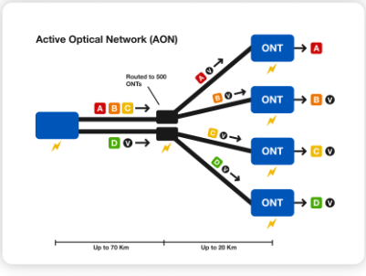

Bandwidth: a range of frequencies within a given band, in particular that used for transmitting a signal

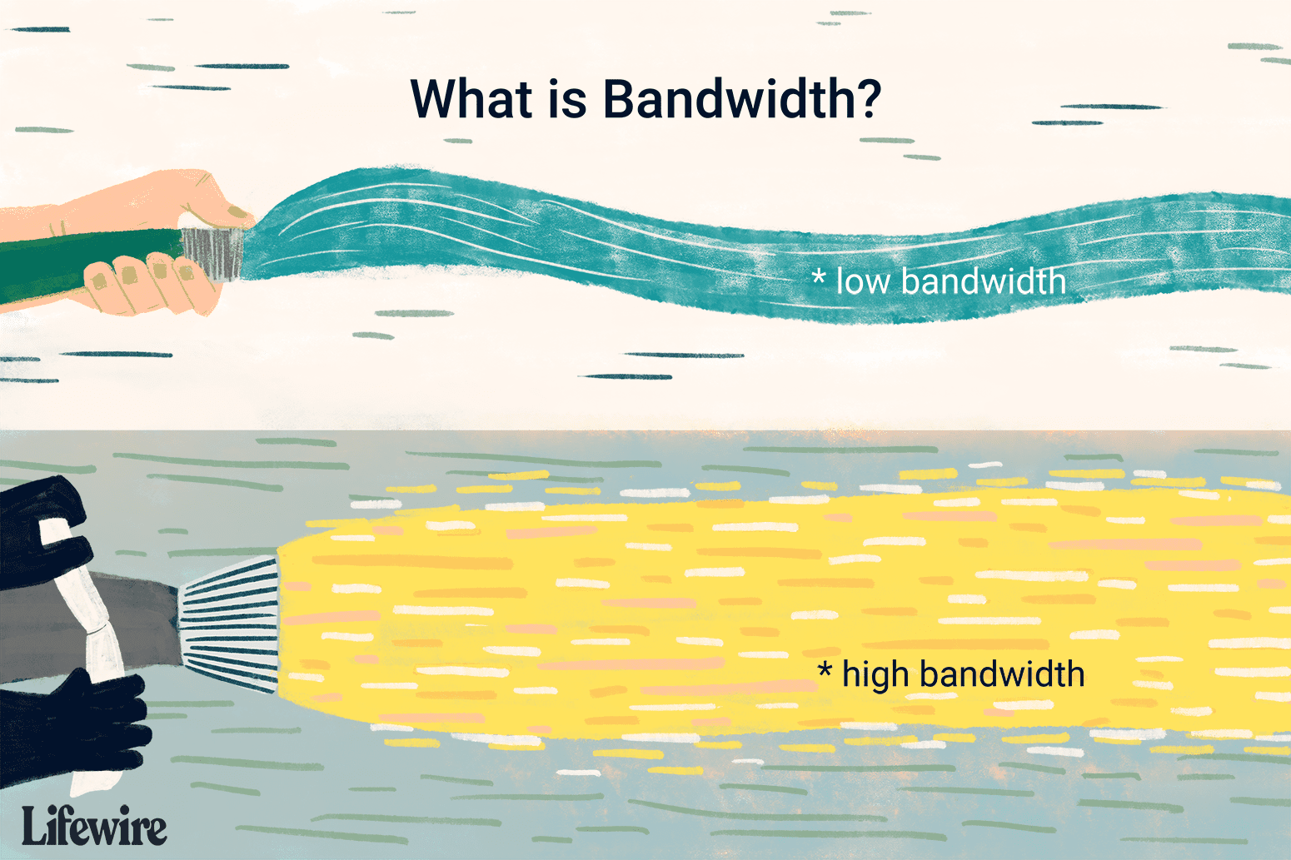

Bit rate: the number of bits used per second to represent a continuous medium such as audio or video after source coding

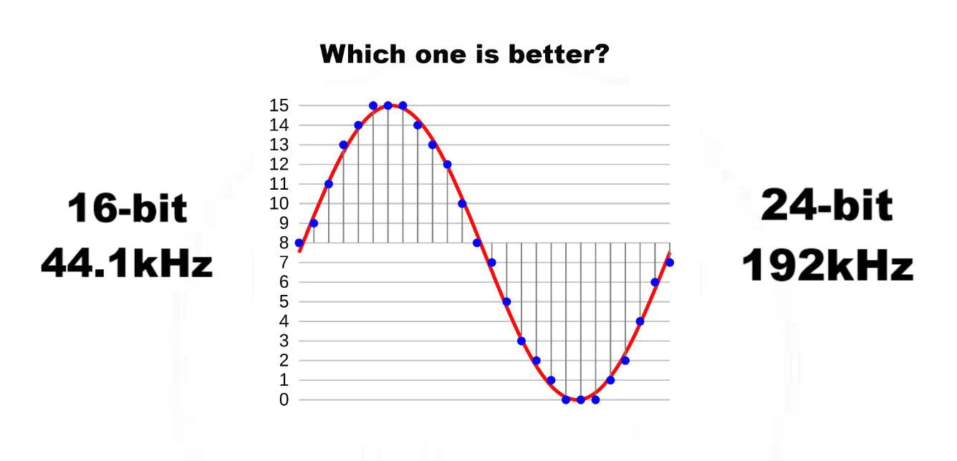

Cable Internet access: a form of broadband Internet access which uses the same infrastructure as a cable television

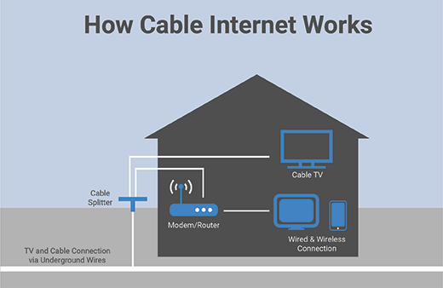

Clients: a person or organization using the services

Communication links: a connection between a hyperlink or graphical element (button, drawing, image)



Digital subscriber line access multiplexer: a network device, often located in telephone exchanges, that connects multiple customer digital subscriber line interfaces to a high-speed digital communications channel using multiplexing techniques.

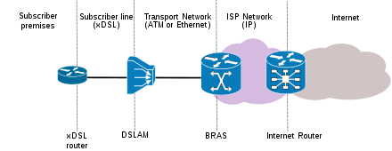

Edge router: a specialized router located at a network boundary that enables an internal network to connect to external networks.

End systems: a computer connected to a computer network is sometimes referred to as an end system or end station because it sits at the edge of the network.

Fiber to the home: is the installation and use of optical fiber from a central point directly to individual buildings such as residences, apartment buildings and businesses to provide high-speed internet access

Hosts: a computer or other device that communicates with other hosts on a network.

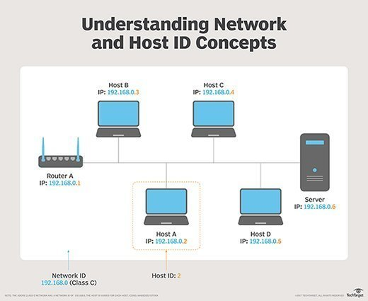

Latency: a synonym for delay. In telecommunications, low latency is associated with a positive user experience (UX) while high latency is associated with poor UX

Link-layer switches: A network switch is a device that operates at the Data Link layer of the OSI mode

Local Area Network: a group of computers and peripheral devices that share a common communications line or wireless link to a server within a distinct geographic area.

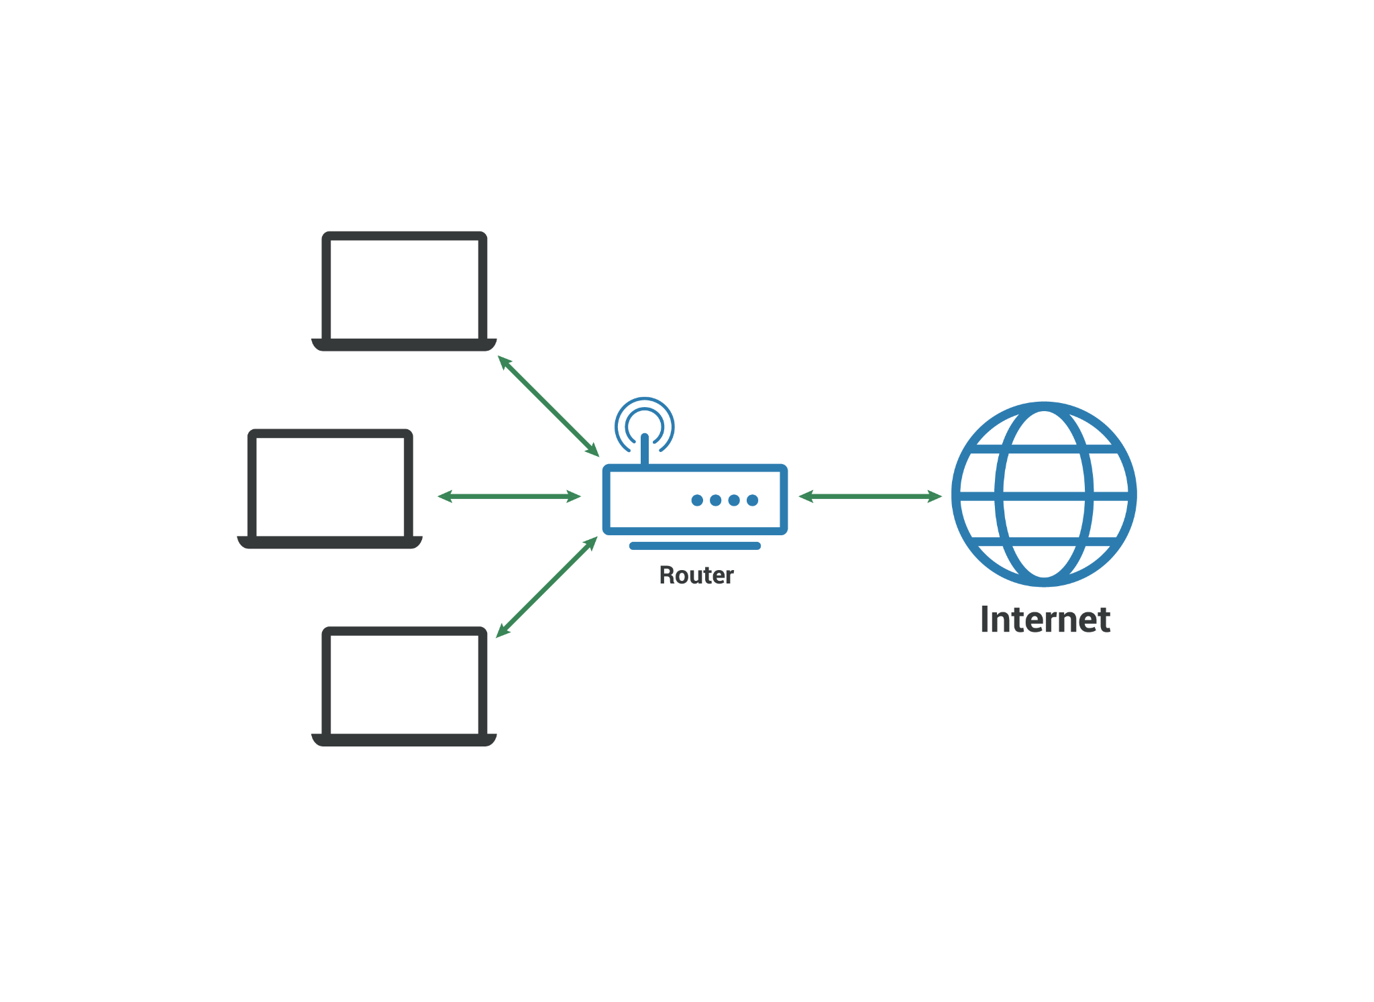

Net Neutrality: the principle that Internet service providers (ISPs) must treat all Internet communications equally, and not charge users different rates based on content, website, platform, application, type of equipment, source address

Network architecture: a network's structural and logical layout

Network Redundancy: a duplicated infrastructure where additional or alternate instances of network devices and connections are installed to ensure an alternate path in case of a failure on the primary service

Packet: a small segment of a larger message. Data sent over computer networks\*, such as the Internet, is divided into packets

Packet switches: a mode of data transmission in which a message is broken into a number of parts that are sent independently, over whatever route is optimum for each packet, and reassembled at the destination.

Passive optical networks: a fiber-optic telecommunications technology for delivering broadband network access to end-customers

Path: consists of nodes and path segments that connect nodes to other nodes

Route: the process of selecting a path across one or more networks.

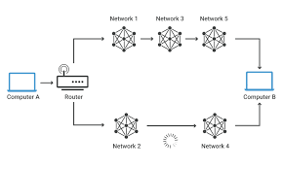

Routers: a device that connects two or more packet-switched networks or subnetworks.

Splitter: a device used to split the cable signal to two or more devices

Telecommunications: the means of electronic transmission of information over distances

Transmission rate: the volume of data transmitted over a transmission channel or via a data interface within a specified unit of time.

URL: a reference (an address) to a resource on the Internet.

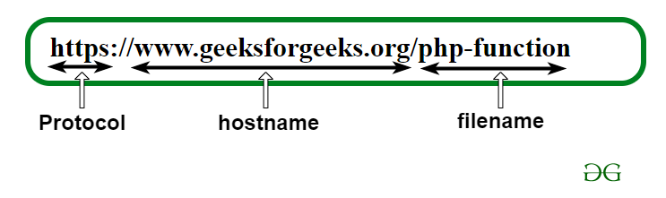

Utility program: software programs that add functionality to your computer or help your computer perform better.

Wide Area Network: a large network of information that is not tied to a single location

